Megan Weiss
ANT 301
May 12th, 2015
1D Family: Affective Dimensions of an Online Fandom Community

It is no secret that many people, especially young people, spend lots of time on social media, but what are they actually doing while they’re scrolling through their phones or staring for hours at a computer screen? Tom Boellstorff stipulates that many of these individuals are taking part in what he terms “virtual worlds.” A virtual world is any “computer generated physical space that can be experienced by many people at once” (Boellstorff, 2010). In his book, Coming of Age in Second Life, Boellstorff took a look at one of these so-called worlds, and came to the conclusion that these spaces provided individuals with opportunities to create a new kind of sociality that was, in fact, not at all inferior to real life relationships. Virtual worlds give way to large groups, emotional and even sexual relationships, and more. These worlds are easy to adapt to because users build their skills on shared knowledge they gain from other users who help them along the way. What Boellstorff wants the greater public to understand is that virtual doesn’t have to mean fake, or dangerous. Furthermore, he feels that ethnography has an important role in researching these worlds so that we can better understand the technological changes that are, in turn, impacting how we express culture. Most of these spaces have thousands of people participating, and these people perform actions and create meanings that in turn create cultural norms within the space. Boellstorff articulates that it is lack of knowledge about virtual worlds and social media spaces that make them seem threatening. In this paper, I will analyze the practices and beliefs taking place in the One Direction fandom community. As a goal, I hope to educate the public on the benefits of being involved in a world that allows individuals from separate places, and even continents, to interact and form both virtual and in-real-life relationships. Finally, I attempt to highlight the affective dimensions of these spaces as they act to form systems of safety, security, and support for users.
Not Just An Imaginary Friend:
Virtual worlds can open the door for so many important, social opportunities. In an online community, such as the One Direction fandom, lots of girls and young women use with love for their band, the individual members, and the music to form important, virtual, yet albeit real friendships with others all over the world (Boellstorff, 2010). In fact, it is not uncommon for a girl from London to befriend another girl from India, or Australia. Likewise, involvement in a virtual world, or online community such as a fandom, can provide young people with the connections to form real life, face-to-face relationships. This kind of environment is especially helpful for those who may suffer from anxieties or other mental and psychological challenges which in turn make it hard to form relationships in the first place. To illustrate, I’d like to cite a personal example in which a virtual connection helped foster one of the most important friendships I will ever make.
Going into my sophomore year of college I was still very much behind in the “adjustment” period. I’d come from a small school district, where I’d spent my days with the same 90 kids from kindergarten to graduation. This meant that leaving for college disrupted the tight family I’d created for myself in high school. I was used to having my close friends around me, and I was used to being highly involved in sports and extra-curricular activities, especially involving music. Coming to Oswego was a bit of a culture shock, because I did not have those same outlets available to me.
I’d gotten to know a small group of regular friends, and I still spoke regularly with my childhood best friend, who was now four hours away at a different school. Despite these factors, however, I still didn’t have the right outlet on campus that would have helped make things just a little bit more bearable. As a result, I found myself turning toward alternate methods of catharsis, namely in the band, One Direction. I’d started listening to their music when their second album came out during my first semester, in the fall of 2012. The interest quickly snowballed into a love, passion, and dedication that helped me get through the toughest times of my first year at Oswego: including my mother’s battle with breast cancer and the death of my grandfather. Overtime I became more involved in online forums where I could express my love and devotion to the boys: Harry, Liam, Niall, Louis, and Zayn; namely on social media sites such as Tumblr and Twitter.
In August of 2013 the boys released their first feature-length film, “This Is Us.” I’d been dying to see it since the band announced the movie’s release early that Spring, and shortly after moving in for the Fall semester, I’d tweeted about wanting to see it. My biggest problem? I didn’t have anyone to see it with. Later, I’d received a direct message from Jordyn, a girl who’d actually been my neighbor freshman year, asking if I would want to go with her.
At this point, Jordyn and I were friends, but only in the sense that we lived across the hall from each other, and had taken a class together. Still, we’d always gotten along well, and I felt comfortable with her, so I decided to take a chance and in early September we had a movie date to see the film.
I highlight this instance because if I hadn’t tweeted about wanting to see the movie, I may not have had the chance to meet the person who would become one of my dearest friends. Upon arriving to find only four other young girls in the theatre, we allowed ourselves to converse and laugh and squeal whenever the desire arose. After the movie date, we started spending more time together, finding out that our shared interest in the boys was only the base of what would become a solid, real relationship. Other than the boys, we found that we had a lot of the same opinions, loved the same books and movies, and most importantly, I felt safe around her.
For someone like me, who struggles with social anxieties, it can be really hard to open up to people, especially if I haven’t known them very well. The One Direction fandom provided me with a safe building block that let me open up slowly, first about them, and then, as time went on, about other things – even personal things, such as my mental and psychological struggles. The bottom line was that technology had provided me with a different kind of social relationship with a like-minded individual who, without our shared interests, I might not have gotten to know. In our case, the shared experiences we had within the virtual One Direction fandom gave way to a real, healthy friendship. A year and a half after the initial virtual interactions that sparked our eventual relationship, Jordyn and I remain best friends, and now live together on campus.
Breaking Up Is Hard To Do:
It is no secret that most of our generation’s parents and grandparents view the onslaught of text messaging and social media as detrimental to effective communication. But what actually happens when a young person is spending time on Twitter, Facebook, or Tumblr? Are they just mindlessly scrolling through inappropriate, mind-numbing pictures and using grammatically incorrect shorthand? In some cases, maybe. The truth is, however, that many young people today turn to these worlds in order to seek like-minded individuals. Among these individuals they will try to create a home for themselves, in an attempt to gain affective support from someone who understands the world in similar terms.
In creating a Tumblr blog, for instance, each user is establishing themselves in the Tumblr culture. In such a world, they will choose an avatar, which is how each user will imagine themselves in the unfamiliar space (Boellstorff, 2010). In this “convergence of communication and entertainment” communities are formed, such as the 1D Family, or, in other words, fans of One Direction (Sefton-Green, 1998). In the One Direction community, for example, one might choose an image of their favorite member to represent them and their love for that person, as well as the band as a whole. Then, they will move on to choose an overall theme for their blog. They might choose a background showing a picture of all the boys: Harry, Niall, Liam, Louis, and Zayn. They may choose another image of their favorite member. They may choose a general theme that shows off their interest in music, such as vintage cassette tapes, headphones, music notes, instruments, and so forth.
As they move further into the community, their blog posts and activity within the community itself will create an identity for that particular user in the Tumblr world. No matter how they choose to interact within their community of choice, the important thing to emphasize about virtual worlds in general is that they do promote interaction with other people, even if it is through computer screens (Boellstorff, 2010). Also, once someone becomes familiar with Tumblr, or some other particular kind of virtual world, it will become easier, and more common, for them to become part of other virtual communities. Within these communities, it is just as common for the user to develop affective ties to their fellow users, and in the case of the One Direction family, the band and its members, as well. As a result, even in dissolution, this type of community, commonly referenced in pop culture as a “fandom,” enables communities of support, solace, and most importantly, forms strong social bonds.
Imagine a 20-year-old, female college student coming back to her dorm room. She hops on her bed with the sole idea of taking a nap. About to settle against her pillows, she checks her phone and sees a message from her friend.
“WHAT. IS. THIS?” it says. She’s confused at first, because she doesn’t see the picture that’s been attached to the message. Then, her heart seems to stop inside her chest. She scrambles to get her laptop from her desk, and opens up the One Direction Official Facebook page.
““After 5 incredible years, Zayn Malik has decided it’s time for him to leave One Direction…”
She stops reading at the end of the sentence. Wetness pricks at the corner of her eyes. She re-reads the sentence once. Twice. A fifth time.
“This can’t be real,” she says to herself. The boys are supposed to stay together forever – or, at least, for several more years to come. The new tour had just started a month ago, in Australia, and all the boys, especially Zayn, had seemed to so excited and happy to be back on the road performing for their girls again. It was all normal, but then a couple weeks ago the rumors started. And someone started yet another cheating scandal, claiming Zayn was cheating on his fiancé of a year and a half, Perrie. Of course, true fans always knew these rumors were false, but there was no ignoring that each time they must take an emotional toll on the boys, who are still really just kids themselves, ranging in age from 21 to 23. Finally, for Zayn, at least, it had all gotten to be too much.
After she is finally able to read through the rest of the announcement, the girl lays back and tries to focus on just breathing. She feels – funny. She isn’t sad – yet. Or angry. Or scared…or anything, really. She is just confused at how everything has broken apart so fast – so abruptly.
The rest of the day goes by agonizingly slow as she forces herself through another hour and twenty class. She spends hours glued to Twitter and Tumblr, searching for news and solace from her friends online. Everyone is shell shocked – worried that this is the beginning of the end. The fandom community has all the confidence in the remaining four boys, but they’re still worried that this is going to be too hard of a blow for Harry, Liam, Niall, and Louis. After all, they aren’t just losing an idol, they are also losing a brother. Sure, they will still be good friends and all, but it won’t be the same. No more bus 1. No more daddy Zayn taking care of his “little brothers.” No more Louis and Zayn causing trouble. No more Liam and Zayn hugging and cuddling on stage. No more Harry/Zayn harmonies. And no more Zayn protecting his baby bro Niall.
Still, this girl has to admit that she feels happy to be part of something so close, because her fandom has pulled together in seconds to support Zayn, as well as Harry, Niall, Liam, and Louis, who are still faced with finishing out their first leg of their tour. Everyone is hurting, and just like how any other family pulls together during a time of loss and despair, the One Direction community turns to each other for support. Masterposts and tweets dedicated to Zayn’s best moments clog dashboards and newsfeeds, wishing him all the best for his future endeavors. Also, tweets and messages are sent out to Niall, Louis, Liam, and Harry making sure they know that they aren’t going to lose their fans over this – their girls. It is a long night, but eventually, Liam reaches out, and the support of the fandom seems to have made an impact.
“In light of recent events I think this is important to say: For the past five years now I've been part of something so special I don't think any of us really understand, something that can mean the world to people and put a smile on the face of our fans even in the darkest times. To a lot of people it's just a bunch of silly kids in a band but to the people involved it means so much more. This last week has been some of the worst times, possibly the worst it's something we are all deeply saddened by. It's sad to think for the time being we won't grace the stage as five bros or have the same fun on a tour bus or laughs in a hotel together that we have over the years but I'm super sure us and zayn will always remain the closest friends. I guess what I'm really trying to say is it's far from over. When we very 1st became successful we all agreed that one direction had become much bigger than each individual member that's why I feel like right now it's ok to be sad and upset but I do ask everyone who is a fan of us to please keep ur faith in us I'm sure there's a lot more to come. All the love, Liam.”
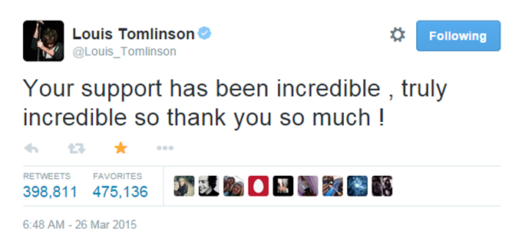
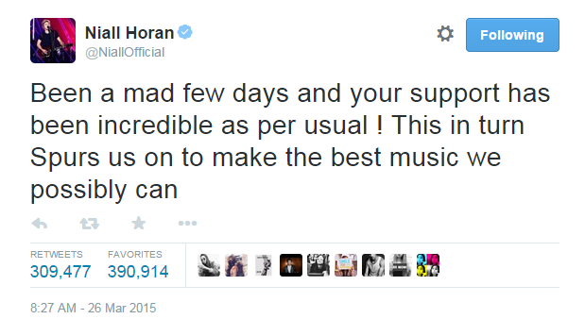
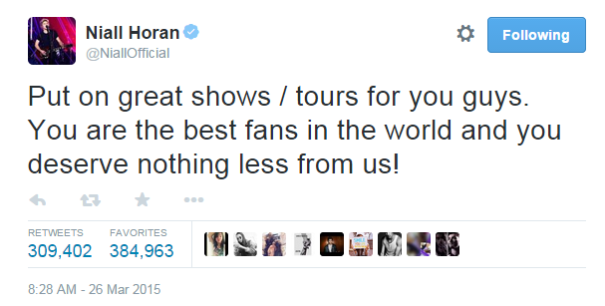
Together, the girl and her friends ensured that Zayn’s departure from the band wasn’t the end for the boys, just a new beginning. The fans want them to know that with their girls behind them, everyone would be okay.
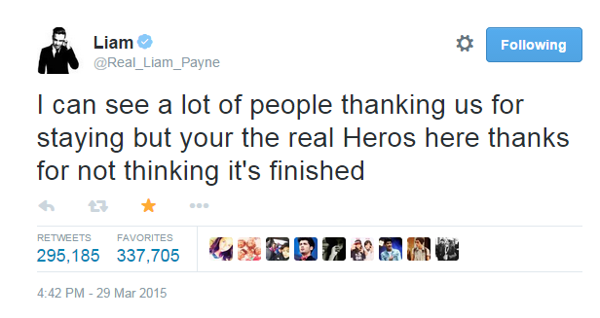
The most important thing about being part of a community like this, the girl realized, was that she, the fans, and the boys could be each other’s heroes. When someone was knocked down, the rest rallied around them to make sure they had a shoulder to cry on. Together, they made sure that the boys got back up again. Learning how to interact and communicate is an essential life skill to any young person growing up in modern society, and through the One Direction community young women not only have the power to make friends and have a little fun, but to be part of something that lets them make a difference in other people’s lives, as well as their own. By being part of such a community, young people use their love for each other, and their common interests, to prove that single people, spread throughout the world, can still come together when necessary and be a positive force. In a fandom, girls can experience myriads of emotions: happiness, sadness, excitement, love, anger, fear, etc. The benefits come from them, as a result, learning how to apply and act on them accordingly.
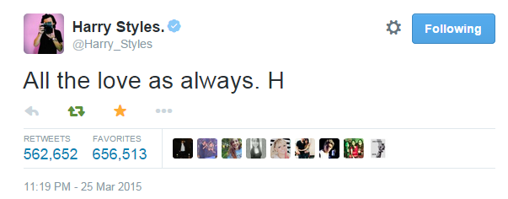
“Virtual” doesn’t have to mean fake. In fact, virtual worlds and relationships are just as real as the physical ones we experience and live in every day. Furthermore, it is not uncommon for these virtual relationships to create a new kind of sociality in which the virtual fosters the real. All the “virtual world” is doing is acting as a venue for these relationships to take place. In a virtual world there are countless opportunities for learning, business, and more that though are computer generated, are being controlled and experienced by real, live people. That fact is that too many people believe that there has to be such a distinct, strict gap between what is virtual and what is actual. The real truth is that the virtual worlds and the experiences that come with them rely on blurring those boundaries.
By learning to adapt and participate in a virtual world, like the One Direction fandom community on Tumblr or Twitter, where users are constantly communicating, protesting, creating and more, people are using their shared knowledge as members to create a virtual self, that can eventually help them participate in the outside world as well. Humanity lies in being virtual in some way (Boellstorff, 2010). Virtuality helps characterize us, and it is only through this medium that so many people can learn how to create individual identities for themselves, together.

Citations:
- Boellstorff, T. (2010). Coming of Age in Second Life: An Anthropologist Explores the Virtually Human (pp. 1-33). N.p.: Princeton University Press.
- Sefton-Green, J. (1998). Digital Diversions: Youth Culture in the Age of Multimedia. N.p.: UCL Press.

